**Name:** Vineel Sai

**Reg No:** 498

**IIIT Kalyani, Assignment 2 8081 Micro controller**

**PROB.1** ONE 16 BIT NUMBER IS IN 3OH(MSB) AND 31H. ANOTHER NUMBER IS IN

MEMORY LOCATIONS 32H (MSB)AND 33H. ADD THE NUMBERS AND STORE THE

RESULT IN 34H(MSB) AND 35H.

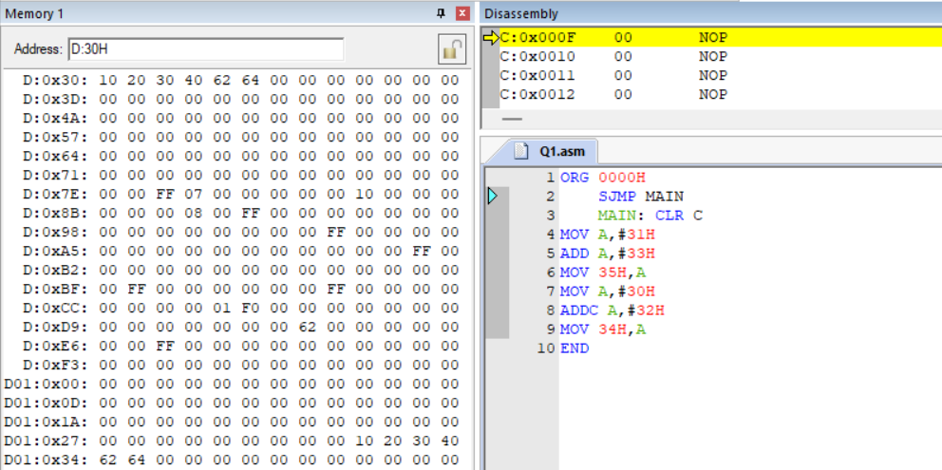

**PROB.2** TREAT R6-R7 AND R4-R5 AS TWO 16 BIT REGISTERS. PERFORM

SUBTRACTION AND STORE THE RESULT IN 34H (LOWER BYTE) AND 35H (HIGHER

BYTE).

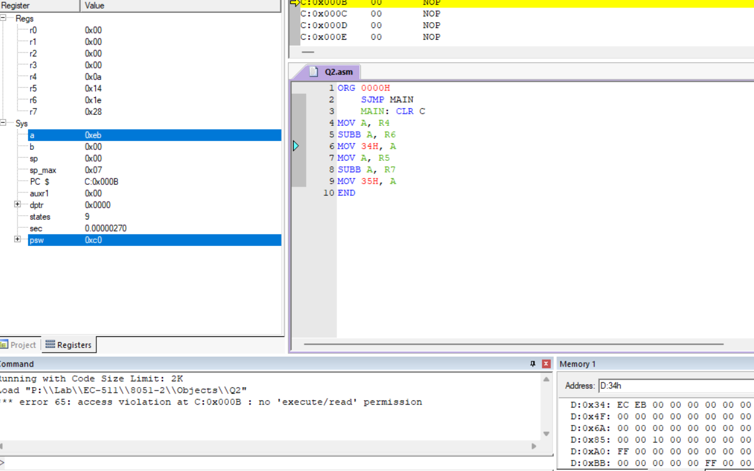

**PROB.3** EXCHANGE THE CONTENT OF FFH AND FF00H.

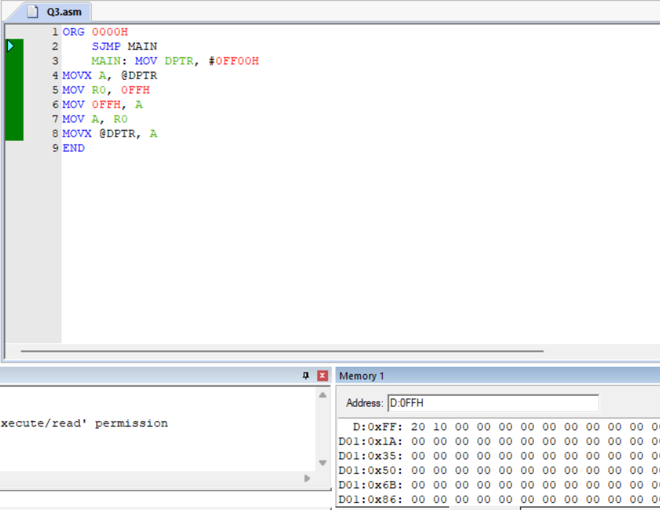

**PROB.4** TRANSFER THE BLOCK OF DATA FROM 30H TO 40H TO EXTERNAL

LOCATION 1030H TO 1040H.

